SHRI DATTA MEGHE POLYTECHNIC, NAGPUR
DEPARTMENT OF COMPUTER TECHNOLOGY
SESSION 2019-20



Report of Micro Project for the subject Advanced Java Programming (22517)

On

TITLE OF PROJECT

Develop a Tic Tac Toe Game in Swing

Submitted By

1.Karan Kurani

2. Riddhi Hedaoo

3. Sahil Wadhigre

Group No.1
Fifth Semester
COMPUTER TECHNOLOGY

Guide
Mrs.H.K.Wankhede
Title of the Project: Develop a Tic Tac Toe Game in Swing.

Project Introduction:

Tic Tac Toe is a fun game to play .Before discussing tic tac toe java code , we should learn about the rules and regulations first.
This game has many variants , but the 3x3 variant is most popular .
This game is played between two players . Tic tac toe java program here is written for applet .The game has simple 3 rows and 3 columns , so make it a 3x3 grid.
Rules of the Game
The player whose turn is first has the choice to mark X or O to one of the nine squares , Here we choose X for first player .
Second player then mark its symbol O in the remaining 8 squares
The thumb of the rule is to make the three successive square grids of the same sign , it does not matter whether they are horizontal , vertical or diagonal , they just need to be three consecutive squares filled with same symbol X or O.
First player who is able to make three consecutive squares with same symbol WINS .

Algorithm:

- Change your fields' visibility to private as others object shouldn't know (nor care) about the inner working of your TicTacToe, this is known as Encapsulation
- Turn the buttons into a 2D array and make the name clearer (b isn't really informative )
- Avoid magic numbers (talking about 3, 9, 500 which can be replaced by GRID_LENGTH, GRID_SIZE...) : this way, not only it's clearer for a newcomer but if you ever change one value it'll be updated everywhere
- I don't think there is any point in making win a field, it's only used like a local variable
- Turn the // WHO WON part into a method that'll do all the checks for you and return you a Boolean : in general, calling multiple short methods makes for a clearer code as the code is more declarative this way (and it removes useless comments)
- For same reasons as above, turn the victory message printing into its own method
- Use a for loop to check every lines and every columns without caring for their size, that'll make for a clearer code and it'll also be easier to modify the current behavior (if you ever want to allow for different grid size)
- You may want to not compute diagonals unless someone has checked one of the diagonal value, it'll probably slight increase cyclamate complexity though so it's up to you ;)
- You forgot to disable the buttons if the game ends in a tie... in the same way as points 5 and 6, creating a disableTicTacToe or disableFrame method may be neat
- Maybe you should consider offering the players a new game when one has ended

UML Diagram /Flowchart as per requirement:

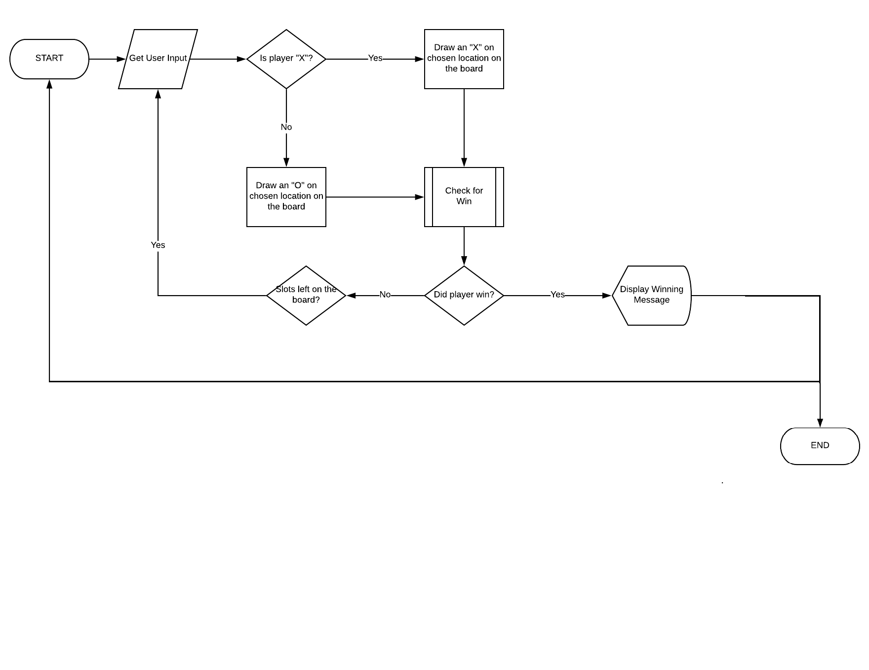
Source Code:

TicTacToe.class

import javax.swing.*;
import javax.swing.JFrame;
import java.awt.*;
import javax.swing.JButton;
import javax.swing.ImageIcon;
import java.awt.event.*;
import java.awt.event.ActionEvent;

public class TicTacToe extends JFrame implements MouseListener{
JPanel p=new JPanel();
XOButton buttons[]=new XOButton[9];

public static void main(String args[]){
new TicTacToe();

}

public TicTacToe(){
super("TicTacToe");
setSize(400,400);
setResizable(false);
setDefaultCloseOperation(EXIT_ON_CLOSE);
p.setLayout(new GridLayout(3,3));
for(int i=0;i<9;i++)
{
buttons[i]=new XOButton();
p.add(buttons[i]);
buttons[i].addMouseListener(this);
}
add(p);
setVisible(true);
}
public void mousePressed(MouseEvent me) { }
public void mouseReleased(MouseEvent me) { }
public void mouseEntered(MouseEvent me) { }
public void mouseExited(MouseEvent me) { }
public void mouseClicked(MouseEvent me)
{

ImageIcon icon = new ImageIcon("win.png");
for(int i=0 ; i<9 ; i+=3)
{
int j=1,k=2;

if(buttons[i].ind == buttons[i+j].ind && buttons[i].ind == buttons[i+k].ind )
{
if(buttons[i].ind == 1)
{
JOptionPane.showMessageDialog(this, " X WIN THE GAME ", "Winner",JOptionPane.INFORMATION_MESSAGE,icon);
clearButtons();
}
if(buttons[i].ind == 2)
{
JOptionPane.showMessageDialog(this, " O WIN THE GAME ", "Winner",JOptionPane.INFORMATION_MESSAGE,icon);
clearButtons();
}
}
int x = 3,y=6;
int z = i;
if(i == 3)
{
z = 1;
}
if(i == 6)
{
z = 2;
}
if(buttons[z].ind == buttons[z+x].ind && buttons[z].ind == buttons[z+y].ind )
{
if(buttons[z].ind == 1)
{
JOptionPane.showMessageDialog(this, " X Won the game ");
clearButtons();
}
if(buttons[z].ind == 2)
{
JOptionPane.showMessageDialog(this, " O Won the game ");
clearButtons();
}
}
}
if(buttons[0].ind == buttons[4].ind && buttons[0].ind == buttons[8].ind )
{
if(buttons[0].ind == 1)
{
JOptionPane.showMessageDialog(this, " X Won the game ");
clearButtons();
}
if(buttons[0].ind == 2)
{
JOptionPane.showMessageDialog(this, " O Won the game ");
clearButtons();
}

}
if(buttons[2].ind == buttons[4].ind && buttons[2].ind == buttons[6].ind )
{
if(buttons[2].ind == 1)
{
JOptionPane.showMessageDialog(this, " X Won the game ");
clearButtons();
}
if(buttons[2].ind == 2)
{
JOptionPane.showMessageDialog(this, " O Won the game ");
clearButtons();
}

}
checkTie();
}

public void checkTie()
{
int flag = 0;
for(int i=0;i<9;i++)
{
if(buttons[i].ind == 0)
{
flag = 1;
}
if(flag == 1)
{
break;
}
}
if(flag == 0)
{
JOptionPane.showMessageDialog(this," It's a tie ");
for(int i=0;i<9;i++)
{
buttons[i].setIcon(null);
buttons[i].ind = 0;
}
}
}
public void clearButtons()
{
for(int i=0;i<9;i++)
{
buttons[i].setIcon(null);
buttons[i].ind = 0;
}
}

}

XOButton.class

import javax.swing.*;
import javax.swing.ImageIcon;
import java.awt.event.*;
import java.awt.event.ActionEvent;
import java.awt.*;

public class XOButton extends JButton implements MouseListener{
ImageIcon X,O;
int ind = 0;
/*
0:nothing
1:X
2:O
*/

public XOButton(){
X=new ImageIcon(this.getClass().getResource("X.png"));
O=new ImageIcon(this.getClass().getResource("O.png"));
this.addMouseListener(this);
}
public void mousePressed(MouseEvent me) { }
public void mouseReleased(MouseEvent me) { }
public void mouseEntered(MouseEvent me) { }
public void mouseExited(MouseEvent me) { }
public void mouseClicked(MouseEvent me) {

if(me.getButton() == MouseEvent.BUTTON1) {
setIcon(X);
ind = 1;
}
if(me.getButton() == MouseEvent.BUTTON3) {
setIcon(O);
ind = 2;
}

}
}

Output:
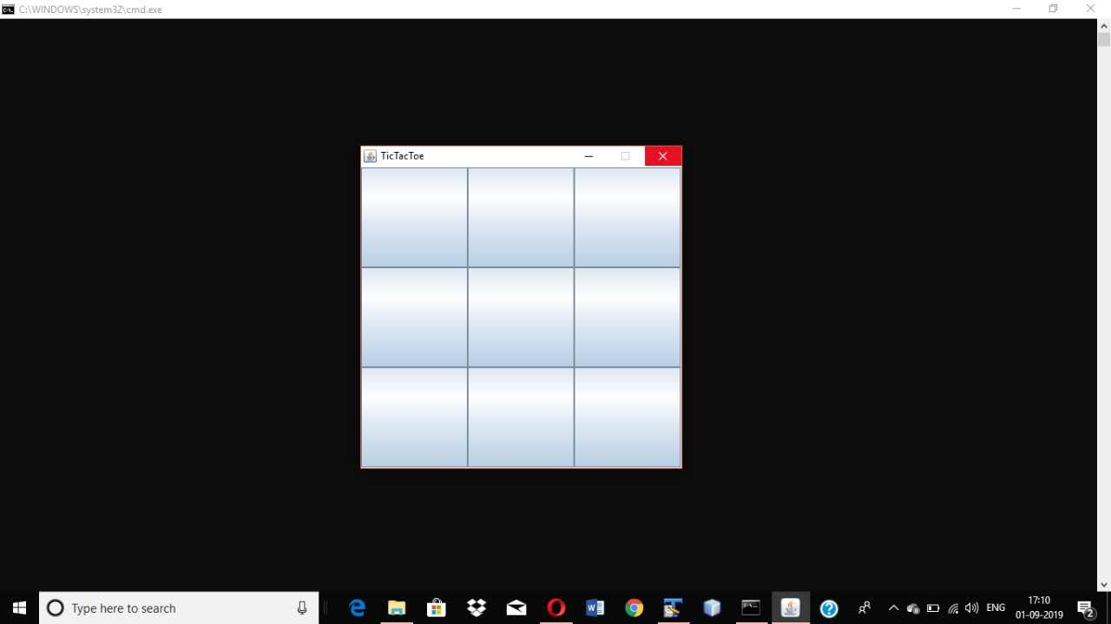
Fig 1:-Starting screen of TIC TAC TOE
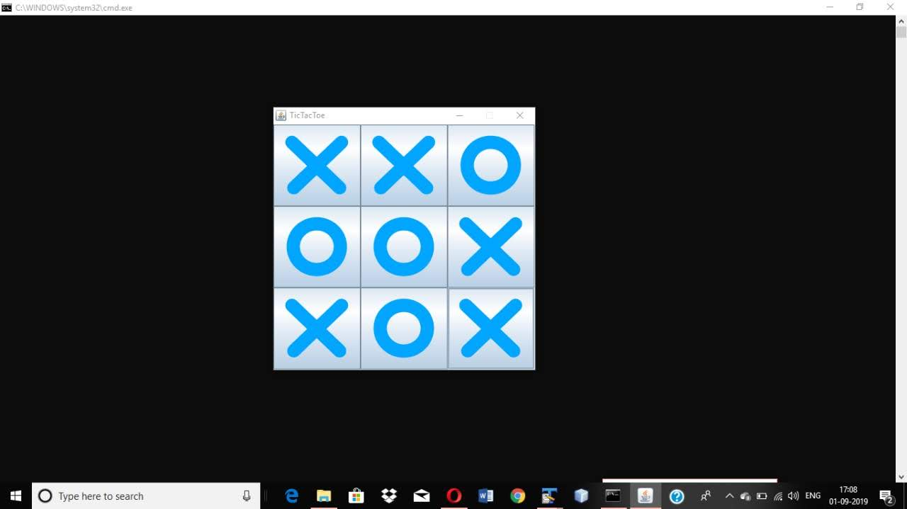Fig 2:- First player who is able to make three consecutive squares with same symbol WINS .
Here are the display messages:-

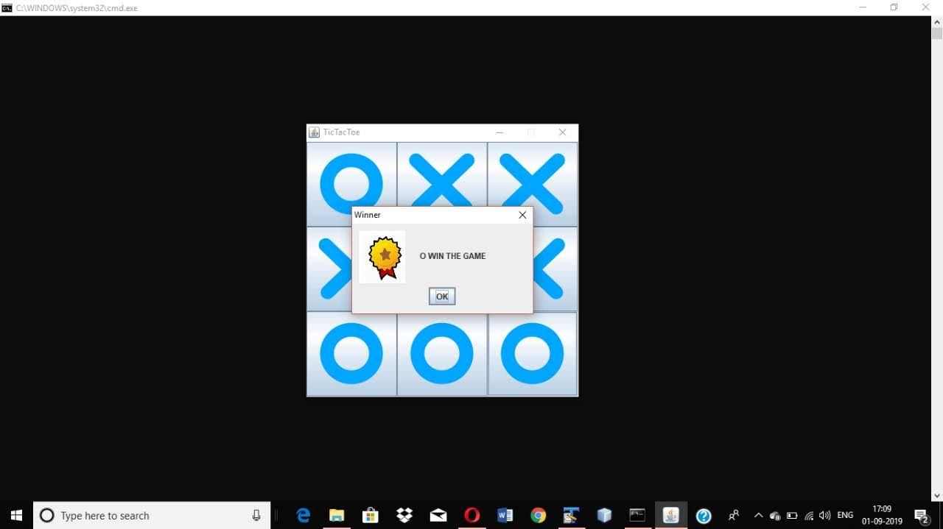

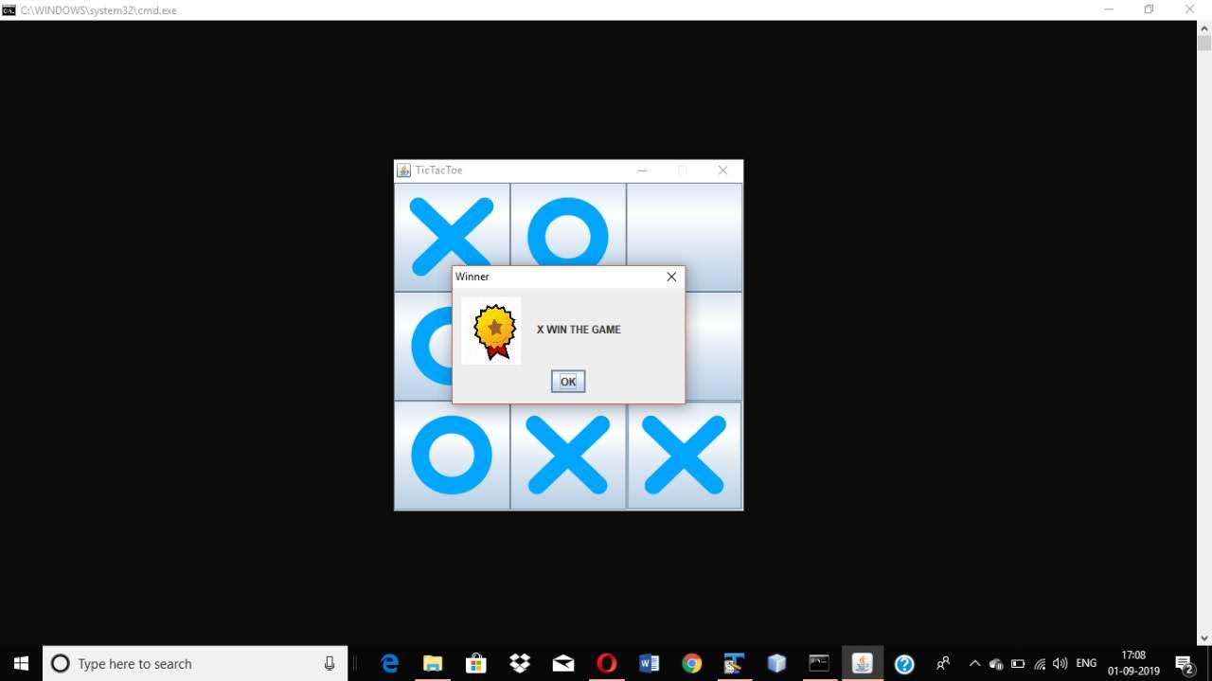

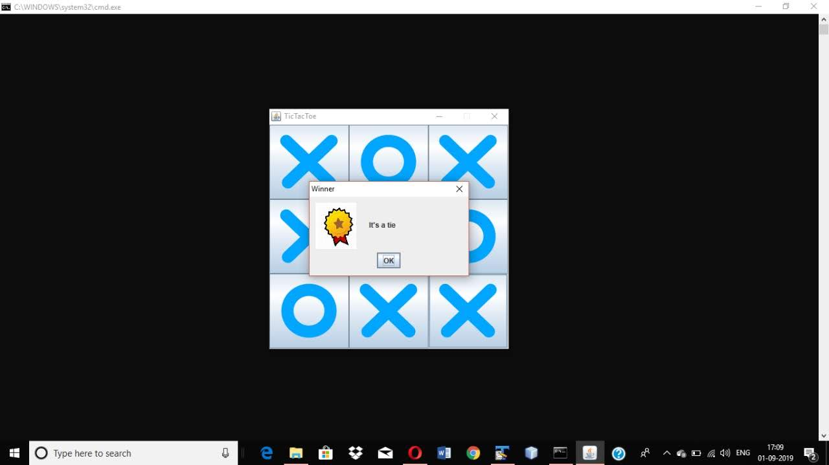

References:

https://www.youtube.com/watch?v=Db3cC5iPrOM&t=26s
https://www.javatpoint.com/

